**[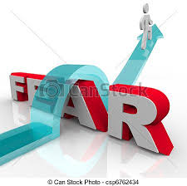](http://www.google.com/imgres?imgurl=http%3A%2F%2Fimages.clipartpanda.com%2Fcourage-clipart-can-stock-photo_csp6762434.jpg&imgrefurl=http%3A%2F%2Fwww.clipartpanda.com%2Fclipart_images%2Fbravery-and-courage-needed-8830007&h=447&w=450&tbnid=6GmQU3ingcWAWM%3A&zoom=1&docid=tpLQDOTZf-n8rM&hl=en&ei=dK0UVJPVD8GlyAT88YL4Dg&tbm=isch&ved=0CFYQMygbMBs&iact=rc&uact=3&dur=427&page=2&start=16&ndsp=29)**

[](http://www.google.com/imgres?imgurl=http%3A%2F%2Fsr.photos2.fotosearch.com%2Fbthumb%2FCSP%2FCSP465%2Fk4654328.jpg&imgrefurl=http%3A%2F%2Fwww.fotosearch.com%2Fillustration%2Fself-confidence.html&h=129&w=170&tbnid=ZeYrFWYBjDylzM%3A&zoom=1&docid=Gk1ejB810MKKNM&hl=en&ei=YrMUVKrhJ5euyAT9pIHoDQ&tbm=isch&ved=0CGIQMygnMCc&iact=rc&uact=3&dur=989&page=2&start=15&ndsp=29)[](http://www.google.com/imgres?imgurl=http%3A%2F%2Fwww.gallaudet.edu%2FImages%2FAcademic%2FFYE%2FSSnewlogo2.jpg&imgrefurl=http%3A%2F%2Fehhsdean.com%2F&h=354&w=531&tbnid=N3MfXeafb5CgIM%3A&zoom=1&docid=HgqkL0Gswv44dM&hl=en&ei=BbIUVPKJLc6ryATqlYKYDw&tbm=isch&ved=0CFEQMyhJMEk4ZA&iact=rc&uact=3&dur=918&page=7&start=163&ndsp=28)[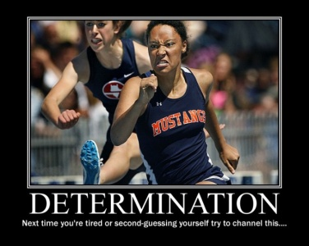](http://www.google.com/url?sa=i&source=images&cd=&cad=rja&uact=8&docid=dvnHe5CoIc4B5M&tbnid=kjm_j180dQcGhM&ved=0CAgQjRw&url=http%3A%2F%2Futahphotojournalism.com%2F2011%2F05%2Fdetermination-poster%2F&ei=OK8UVJuzDpSyyASEg4GgBw&psig=AFQjCNFMpzXAUkqBxsLZrBsSOOdVxAONRw&ust=1410728120325188)[](http://www.google.com/imgres?imgurl=http%3A%2F%2Fcomps.canstockphoto.com%2Fcan-stock-photo_csp10836073.jpg&imgrefurl=http%3A%2F%2Fwww.canstockphoto.com%2Fillustration%2Fendurance.html&h=470&w=450&tbnid=P2XrbK-3i23x0M%3A&zoom=1&docid=DjqtoaJJO-c7NM&hl=en&ei=87AUVIKQHMKNyASmkIGoAQ&tbm=isch&ved=0CEcQMyg_MD84ZA&iact=rc&uact=3&dur=552&page=7&start=141&ndsp=26)[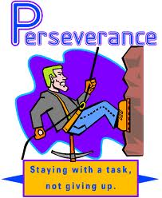](http://www.google.com/imgres?imgurl=http%3A%2F%2Fstatic3.echalk.net%2Fwww%2Facboe_ny%2Fsite%2FImageGallery%2Faandreatos%2FPerseverance.gif&imgrefurl=http%3A%2F%2Fny.acboe.org%2Fsite_view_calendar.aspx%3Fid%3Dc7bae75f-3747-4be1-bc19-681667bc20c9%26date%3D2%252F1%252F2013&h=722&w=590&tbnid=AvQiYAD5THJtHM%3A&zoom=1&docid=cFawdprHqIvzbM&hl=en&ei=KLAUVI22E4z_yQTly4GQBA&tbm=isch&ved=0CFkQMygeMB4&iact=rc&uact=3&dur=2320&page=2&start=14&ndsp=29)